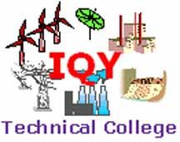
ENROLMENT FORM
The student needs to provide the following information.
NAME

MALE or FEMALE

PROGRAMS | PUT ( X ) BESIDE
 | Master of Engineering (Electrical) IPEMTU/STC Technological University (3L online)
 | Master of Engineering (Electrical) ISCPU School of Engineering Switzerland (USD4000 online)
 | Master of Engineering (Civil) IPEMTU/STC Technological University (3L online)
 | Master of Engineering (Civil ISCPU School of Engineering Switzerland (USD4000 online)
 | Master of Engineering (Mechanical) IPEMTU/STC Technological University (3L online)
 | Master of Engineering (Mechanical) ISCPU School of Engineering Switzerland (USD4000 online)
 | Master of Engineering (ICT) IPEMTU/STC Technological University (3L online)
 | Master of Engineering (ICT) ISCPU School of Engineering Switzerland (USD4000 online)
 | Master of Science (IT) IPEMTU/STC Technological University (3L online)
 | Master of Science (IT) St Clements University (3L online)+USD500
 | Master of Business Management St Clements University (3L online)+USD500
 | Professional Diploma in Electrical Engineering(IQY/SIET)/Bachelor of Engineering (Electrical) IPEMTU/STC Technological University (2L online)
 | Professional Diploma in Electrical Engineering(IQY/SIET)/Bachelor of Engineering (Electrical) IPEMTU/STC Technological University (6.3L -6 months personal attendance+ online)
 | Professional Diploma in Electrical Engineering(IQY/SIET)/Bachelor of Engineering (Electrical) IPEMTU/STC Technological University (6.3L -6 months personal attendance+ online)+ St Clements University Myanmar College Degree USD500
 | Professional Diploma in Civil Engineering(IQY/SIET)/Bachelor of Engineering (Civil) IPEMTU/STC Technological University (2L online)
 | Professional Diploma in Civil Engineering(IQY/SIET)/Bachelor of Engineering (Civil) IPEMTU/STC Technological University (6.3L- 6 months personal attendance+ online)
 | Professional Diploma in Civil Engineering(IQY/SIET)/Bachelor of Engineering (Civil) IPEMTU/STC Technological University (6.3L -6 months personal attendance+ online)+ St Clements University Myanmar College Degree USD500
 | Professional Diploma in Mechanical Engineering(IQY/SIET)/Bachelor of Engineering (Mechanical) IPEMTU/STC Technological University (2L online)
 | Professional Diploma in Mechanical Engineering(IQY/SIET)/Bachelor of Engineering (Mechanical) IPEMTU/STC Technological University (6.3L 6 months personal attendance+ online)
 | Professional Diploma in Mechanical Engineering(IQY/SIET)/Bachelor of Engineering (Mechanical) IPEMTU/STC Technological University (6.3L 6 months personal attendance+ online)+ St Clements University Myanmar College Degree USD500
 | Professional Diploma in Renewable Energy Engineering(IQY/SIET)/Bachelor of Engineering (Mechanical) IPEMTU/STC Technological University (2L online)
 | Professional Diploma in Renewable Energy Engineering(IQY/SIET)/Bachelor of Engineering (Renewable Energy) IPEMTU/STC Technological University (6.3L 6 months personal attendance+ online)
 | Professional Diploma in other Engineering(IQY/SIET)/Bachelor of Engineering (other) IPEMTU/STC Technological University (2L online)
 | Write the name of discipline that you want to attend
 | Professional Diploma in other Engineering(IQY/SIET)/Bachelor of Engineering (other) IPEMTU/STC Technological University (6.3L 6 months personal attendance+ online)
 | Write the name of discipline that you want to attend
 | Professional Diploma in other Engineering(IQY/SIET)/Bachelor of Engineering (other) IPEMTU/STC Technological University (6.3L 6 months personal attendance+ online)+ St Clements University Myanmar College Degree USD500
 | Write the name of discipline that you want to attend
Professional Diploma in Management (IQY)/ Bachelor of Business Management (STC Technological University)
2L Online
Professional Diploma in Management (IQY)/ Bachelor of Business Management (STC Technological University)
3L Online+ St Clements University Myanmar College degree USD500
 | Professional Diploma in Information Technology (IQY/SIET)/ / Bachelor of Applied Science in Information Technology (STC Technological University)- 2L online
 | Professional Diploma in Information Technology (IQY/SIET)/ / Bachelor of Applied Science in Information Technology (STC Technological University)- 3L online+ St Clements University Myanmar College degree USD500
 | Diploma of Vocational Education & Training / Technical Teaching/ Engineering Education (Free)
 | Diploma in Teaching Practice (Free)
Advanced Diploma in Electrical Engineering(IQY/SIET)
Online 2L
Advanced Diploma in Electrical Engineering(IQY/SIET)
6 months personal attendance + online 3.3L
Advanced Diploma in Civil Engineering(IQY/SIET)
Online 2L
Advanced Diploma in Civil Engineering(IQY/SIET)
6 months personal attendance + online 3.3L
Advanced Diploma in Mechanical Engineering(IQY/SIET)
Online 2L
Advanced Diploma in Mechanical Engineering(IQY/SIET)
6 months personal attendance + online 3.3L
Advanced Diploma in Other Engineering(IQY/SIET)
Online 2L
 | Other engineering- Write the discipline that you want to study
Advanced Diploma in Other Engineering(IQY/SIET)
6 months personal attendance + online 3.3L
 | Other engineering- Write the discipline that you want to study
 | Advanced Diploma in Management (IQY) Online 2L
 | Advanced Diploma in Information Technology (IQY/SIET) Online 2L
 | Diploma in General Engineering and Drafting (THS) + Non Year 10 pass (6 months) personal attendance 3.3L
 | Diploma of Education
 | Diploma in Teaching
 | Bachelor of Education
 | Bachelor of Humanities Studies
 | Master of Humanities Studies
 | Masters degree program -Engineering
 | Masters degree program -Information Technology
 | Masters degree program -Management
 | Masters degree program -Education
 | Master of Applied Arts
 | Doctor of Education
 | Doctor of Engineering
 | Doctor of Business Administration
 | Doctor of Philosophy -Information Technology
 | Diploma of Law
 | Bachelor of Law
 | Master of Law
 | Diploma in Vocational Studies (Diploma in Work Studies-Vocational)
 | Bachelor of Work Studies-Vocational
 | Diploma/Bachelor of Engineering-Rural Development
 | Bachelor of Agricultural Engineering
 | Diploma in Marine Engineering
 | Diploma in Automotive Engineering
 | Master of Applied Arts
 | Doctor of Education
 | Doctor of Engineering
 | Doctor of Business Administration
 | Doctor of Philosophy -Information Technology
 | Diploma of Law
 | Bachelor of Law
 | Master of Law
 | Bachelor of Work Studies-Vocational
 | Diploma/Bachelor of Engineering-Rural Development
 | Bachelor of Agricultural Engineering
 | Diploma in Marine Engineering
 | Diploma in Automotive Engineering
 | Diploma/Bachelor of Work Studies-Sewing Garment
 | Diploma/Bachelor of Work Studies- Cooking
 | Diploma/Bachelor of Work Studies- Childcare
 | Diploma/Bachelor of Work Studies- Aged Care/Nursing
 | Diploma/Bachelor of Work Studies- Waiter/ Reception / Tourism
 | Diploma/Bachelor of Work Studies- Security
 | Diploma/Bachelor of Work Studies- Logistics
 | Diploma/Bachelor of Work Studies- Agriculture
 | Diploma/Bachelor of Work Studies- Animal Handling & Live Stock
 | Diploma/Bachelor of Work Studies-Dancer
 | Diploma/Bachelor of Work Studies-Shop Attendant & Marketing
 | Diploma/Bachelor of Work Studies- Handyman and Asset Maintenance
 | Diploma/Bachelor of Work Studies- /Laundry
 | Diploma/Bachelor of Work Studies- Hair Dressing
 | Diploma/Bachelor of Work Studies- Water Operation
 | Diploma/Bachelor of Work Studies-Store
 | Diploma/Bachelor of Work Studies-Cleaner
 | Diploma/Bachelor of Work Studies-factory
 | Diploma/Bachelor of Work Studies-Maintenance
 | Diploma/Bachelor of Work Studies-Cleaning
 | Diploma/Bachelor of Work Studies-Printing
 | Diploma/Bachelor of Work Studies-Postal Worker/Library
 | Diploma/Bachelor of Work Studies-Teacher Aides
 | Diploma/Bachelor of Work Studies-Production and Industry
 | Diploma/Bachelor of Work Studies-Visual Arts and Crafts
 | Diploma/Bachelor of Work Studies- Screen Media
 | Other Course—Write Below
DATE OF BIRTH
NRC ID CARD NUMBER

ADDRESS
E-MAIL ADDRESS

PHONE/ MOBILE PHONE

NAMES OF FATHER & MOTHER
EDUCATION

EMPLOYMENT IF APPLICABLE
FEES (INTERNATIONAL STUDENTS)
Advanced Diploma only- Australian Dollar 200
Professional Diploma –Australian Dollar 300
Combined Advanced Diploma and Professional Diploma Australian Dollar 500
to be transfer to the following account
To be advised
Then notify by e-mail to iqytechnicalcollege@gmail.com
FEES (MYANMAR STUDENTS)
Please see the fees beside the course
Pay it to your teacher in class. When you start the class please pay to manager
Deposit into bank account (Only for 100% online students) or deposit into the following account.
Registration fees needs to be deposited into Daw Hla Myat Mon – Account Number 020-33-500265-2 (Yoma Bank) / 002044108500265 (Yoma Bank) and attached the evidence of deposit to this application form and then send it to iqytechnicalcollege@gmail.com

Instruction for students
- Read the instruction ,Fill the form & give it to “ Managers”

- Diploma/Advanced Diploma/ Professional Diploma will be awarded upon completion of prescribed units/ courses. They will be awarded electronically.
St Clements University, STC Technological University, UK Management Associations and Singapore Institute of Membership Application fees will be collected separately .
Name of student
Signature ( Put National ID Number & Date of birth that is equivalent to signature)
Date
Name of Manager
Manager’s Signature & Date
OFFICE USE ONLY Recommendation by the academic councillor
Name of academic councillor
Signature ( Name can be put)
Date

Approved by the college.
Name of approver
Signature
Date
Student Number
Affiliated college
Progress of the student |  | Year 1 | Year 2 | Year 3 | Year 4 | Award Number
Put X for the completed action

ADDITIONAL (ONLY FOR MYANMAR STUDENTS)
Instruction for students
- Read the instruction ,Fill the form & give it to “ Managers”
Conditions of enrolment
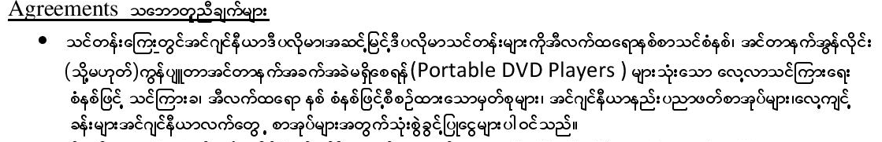
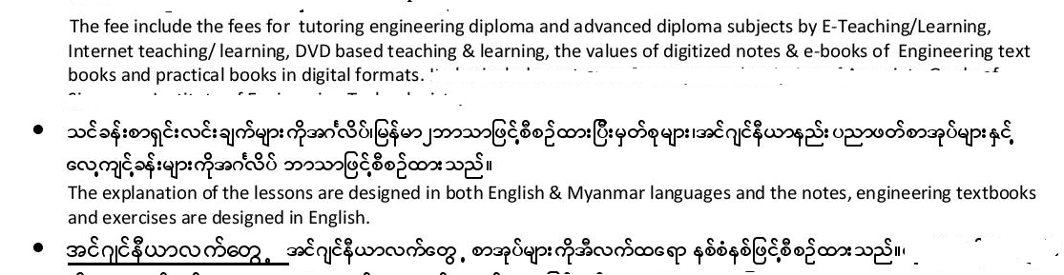
Photo needs to be provided or the manager can take the photo
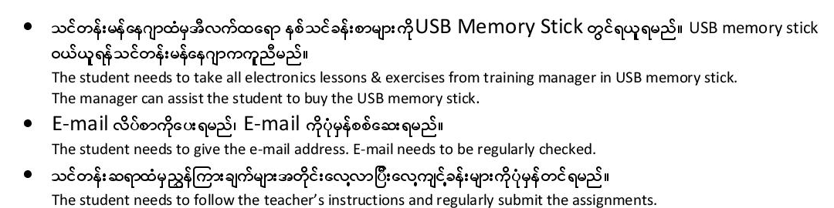
- Diploma/Advanced Diploma/ Professional Diploma will be awarded upon completion of prescribed units/ courses. They will be awarded electronically.
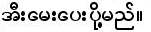
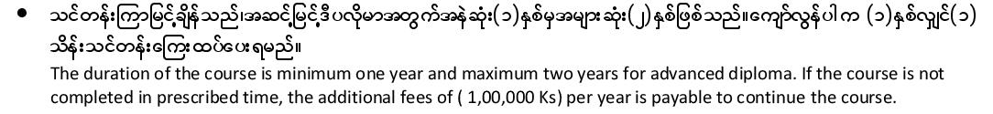
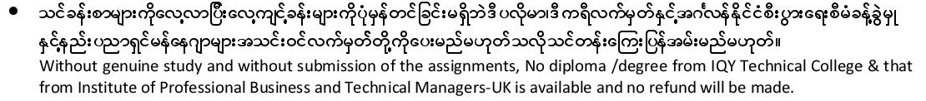
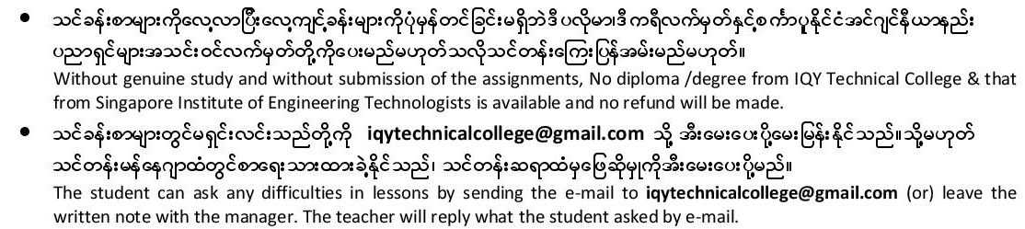
DECLARATION
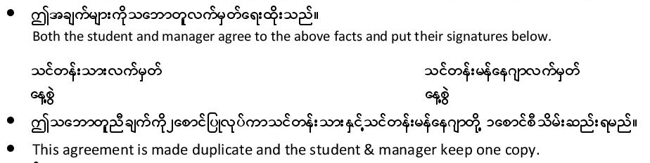
The students can fill the form electronically and both manager and student can keep the electronic copy.

PAYMENT OF FEES FOR YEAR 10 QUALIFICATIONS
Total documents fees for for Advanced Diploma+ Professional Diploma (Kyats)
Total Tuition Fees for Advanced Diploma (Kyats)
 |  | Date | Signed by manager
First Instalment
Second Instalment
Third Instalment
Fourth Instalment

Total Tuition Fees for Professional
Diploma (Kyats)
 |  | Date | Signed by manager
First Instalment
Second Instalment
Third Instalment
Fourth Instalment
PAYMENT OF FEES FOR ADVANCED DIPLOMA LEVEL QUALIFICATIONS
Total documents fees for for Advanced Diploma+ Professional Diploma (Kyats)
Total Tuition Fees for Professional
Diploma (Kyats)
 |  | Date | Signed by manager
First Instalment
Second Instalment
Third Instalment
Fourth Instalment
St Clements University, STC Technological University, UK Management Associations and Singapore Institute of Membership Application fees will be collected separately .
Name of student
Signature ( Put National ID Number & Date of birth that is equivalent to signature)
Date
Name of Manager
Manager’s Signature & Date
OFFICE USE ONLY Recommendation by the academic councillor
Name of academic councillor
Signature ( Name can be put)
Date

Approved by the college.
Name of approver
Signature
Date
Student Number
Affiliated college
Progress of the student |  | Year 1 | Year 2 | Year 3 | Year 4 | Award Number
Put X for the completed action

Remarks & Records

