- Insulated Neutral System--The Reason for Using it Onboard for Ship grounding
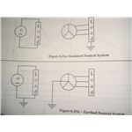
The requirement ashore is the safety of human beings. So, inorder to prevent human-electrical accidents, the neutral is earthed. The priority is neither the safety of the machinery nor the continuous necessary operation of the machinery. But the scenario onboard ship is totally different. The priority is the continuous operation of the machineries which are classed "essential". The distribution system followed onboard is "insulated neutral" system. The main priority onboard is the safety of ship which includes navigation & fire safety..etc. If due to earth fault, the machinery classed as"essential" gets isolated, say for eg: steering gear, then the safety of ship is at question, which may lead to collison, grounding, fire & pollution etc..So the priority onboard ship is to maintain the continuity of the supply to the machinery in the event of "single earth fault occurring".
- slide 3 of 3

Circuit Faults:
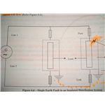A basic circuit consist essentially of Two parts:
1. The Conductor--which carried the current around the circuit.
2. The Insulation---which keeps the current inside the conductor.
Only 2 types of circuit faults can occur. Either break in the insulation or break in the conductor.
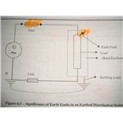
The break in the conductor leads to non-flow of current in the circuit. A break in the insulation leads to an earth fault, allowing the conductor to touch the hull or earthed metal enclosure.
A short-circuit fault is due to the double break in the insulation, allowing both conductors to get connected, thus a very high current passes through, by-passing the load.
A majority of earth faults occurs within the equipment. Generally insulation failure occurs which leads to the conductor getting in contact with the body of the metal enclosure. When such earth faults happen, the metal enclosure of the equipment if not earthed, it would cause a heavy shock, and may result in fire accidents too..
SIGNIFICANCE OF EARTH FAULTS:
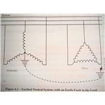
A ship can be considered as a mobile power plant. Most of the machinery is driven electrically, which thus makes for a huge electrical power demand. This makes a shipboard electrical power distribution system very important. This article is about the layout of the main switch board and the bus bar.
- slide 1 of 5

Introduction
Electricity has to be distributed with minimal losses after generation. Unlike a shore based transmission system, where the lengths of the conductors run throughout a country, a shipboard electrical distribution system is short and simple. In this article, the general layout of the main electrical distribution system, along with the main switchboard and emergency switchboard arrangements, will be discussed.
slide 2 of 5

The Main Bus Bar
The main bus bar can be found inside the main switch board. Onboard a merchant ship, the supply is usually 440 volts, 60 Hertz, however higher voltages of 6.6kV are possible on LNG tankers, special purpose ships, and passenger vessels having electrical propulsion. The rating of the main bus bar is decided by the type of ship, the critical machinery on board required for cargo operations, and the machinery required for normal sea service.
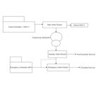
If a ship is steam propelled, it might have steam turbine driven alternators and a diesel driven alternator as a back-up. If the propulsion is by electric motors, then the vessel might require huge diesel driven generators which usually operate at 6.6kV.
Ship Type -------------------------------------------------------Power Requirement
A 10,000 dwt general cargo ship-----------------------------1 MW.
Tankers---------------------------------------------------------- 1.5 to 5 MW.
Containerships (10000 TEU) (3.3kV)-----------------------8 MW
A Modern LNG carrier (Q-max/Q-flex) (6.6kV)------------12 MW
The main bus bar has three heavy, thick bars of conductor (usually copper), running horizontally throughout the length of the main switch board. Each of the conductors is insulated between each other and wherever it is supported or clamped to the switchboard. The bus bar lies at the bottom most portion of the switchboard such that it can be easily supported and insulated. At times, there may be two divisions of the bus bar which are connected to each other by either a circuit breaker or a clamping (sliding contact) device.
The main switchboard is the main power distribution center of the ship. Thus the main bus bars are contained within the switchboard feeding various ship board auxiliaries. A ship may contain two or more generators connected to the main bus bar via the circuit breaker. Various protection for the generators like overload, reverse power, etc. are connected to circuit breaker such that the faulty generator is electrically isolated from the main bus bar. From the main bus bar, the electrical power is supplied to various ship board auxiliaries like pumps, blowers, compressors, etc. The main switch board has various measuring and monitoring devices like ammeters, voltmeters, frequency meters, watt meters, synchroscope, and power factor meters.
A generic layout of a shipboard distribution system is attached here. Refer to the diagram below for the following explanation; however this is just a simplified version of the main power distribution. This may become complex as the size of the vessel and amount of machinery increase in number.
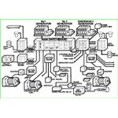
The main switch board gets its supply from the main generators located in the engine room. The distribution system can be divided into Feeder side and the Load side. The feeders are the generators and the loads are various ship board auxiliary machineries. The Load side is further divided into Essential and Non-Essential services. Essential services are very critical auxiliaries which are directly affecting the safety of personnel, ship in terms of navigation and propulsion. They include supply to navigational aids like radars, communication equipment, navigational lights, and steering gear motors. These essential services may be supplied directly from the main switch board or via sectional boards or distribution boards. Non-essential services are those that do not affect the safety of ship and personnel. For example, air conditioning compressors and fans are non-essential services as they don’t affect the safety of the ship or personnel.
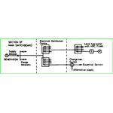
The operating voltage is stepped down to 220 volts and this voltage is given to the 220 Volts auxiliaries’ panel. From this panel, the supply goes for various lighting systems and other sockets for accommodation and galley for domestic use.
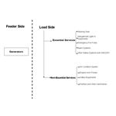
- slide 3 of 5

Distribution Boards/Group Start Panels
Shipboard machinery may not be connected to the main switchboard directly. There are small motors and other devices that consume very little power and thus they may be grouped together. Instead of providing cables for every such individual motor, a single cable is taken out from the main switch board, supplying the distribution board which has a small bus bar (equivalent to supply the motors). From this small bus bar, the supply is provided for various starters of these motors via the circuit breakers. In this way, the protection for the machinery is also precise, as a small fault in such small motors will not operate the protection devices on the main switch board.
