Cover Page Skills Test
Student & Assessor Copy
Unit code | LLN Literacy and Numeracy Assessment
Student Name
Student ID
Date
Student Declaration | I have had time to practice before this assessment.  I understand that this is assessment conducted under simulated work conditions at ETC workshop and facilities  I understand that this is assessment conducted to work standards including WHS legislation in NSW  The Assessor has explained the tasks skills Instructions  I understand that this is a summative assessment.  I understand I must demonstrate the skills myself in the allocated time and answer questions.  I am ready for assessment and sign here.
Student
Signature
SKILL TEST RESULT and FEEDBACK |  |  |  |  |  |  |  | Assessor initials
Result |  | See results in the Skills Task List checkpoints.  See the ‘Unit Skills Test Marking Guide’
 |  | Overall results for the unit Skills test |  |  | (S) |  | (NYS)
Result (1st attempt) |  | YES NO Did student complete the tasks to satisfactory standard at 1st attempt?
Result (2nd attempt) |  | YES NO Did student complete the gap tasks to satisfactory standard at 2nd attempt?  Please note items that were assessed at 2nd attempt –
Feedback to student
Note feedback provided if NYS:

Assessors Name
Assessor's Signature |  |  | Date
Assessor Comment:
Student Declaration |  | I have received the results and feedback for this practical skills test assessment
Student Signature |  |  |  |  |  | Date

Key: | Satisfactory ( S) | Not Yet Satisfactory (NYS)

Instructions to Student and marking guidance

You will be allowed a duration of XXXX hour and XXXX minutes to complete LLN Test
- All students are to follow clear ‘Instructions to Students’ set out at beginning of LLN Test Task Sheet

All Students will participate in a series of skills tests set up and observed by the Assessor.

These skills test will be conducted under simulated conditions at ETC premises.

.
- The Assessor will refer to the ‘Assessor Guide’ and ‘LLN Marking Guide’ for consistent marking and will give you feedback on your performance and responses.
- Candidate to answer the following questions (Yes or No)
1 | Do you understand how this assessment ties into the training? | Y | N
2 | When/where the assessment going to take place and the conditions of the assessment? | Y | N
3 | Are the WHS checks satisfactory and equipment ready for the assessment? | Y | N
4 | Do you feel ready to do the assessment activity? | Y | N
5 | Do you know that the assessment is not pass/fail? Do you know that ETC can re schedule your assessment if you are not ready? The Assessor may set another time for gap assessment or follow up with open questions if there is doubt about your responses or demonstration of skills and knowledge in this practical.  We expect candidates to be successful at the second attempt. | Y | N
6 | Do you know you can appeal the assessment decision if you think it is not fair? | Y | N
7 | Do you have any special needs that we need to adjust for during this assessment? | Y | N
If you ticked NO for anything above, provide more information below.
If you feel not ready for the assessment, talk to the Assessor and do not go ahead.

The assessment contains three parts

- Part 1 Literacy Assessment for the students whom were provided with literacy training and are ready to sit the literacy test.
- Part 2 Numeracy Assessment for the students whom were provided with numeracy training and are ready to sit the numeracy test.
- Part 3 Literacy and Numeracy Assessment for the students whose LLN skills are needed to be assessed and to be rectified to know which aspects need to be improved in Gap training on LLN.

The aim of LLN Assessment is to rectify the LLN needs of the students to provide appropriate assistance rather than determining the competency.
xxxxxxxxxxxxxxxxxxxxxxxxxxxxxxxxxxxxxxxxxxxxxxxxxxxx

Part 1 LLN1 (Literacy)

Read the following passage and answer the questions.
Your reading and writing skills are to be assessed.

Communication in the construction industry
When you work in the construction industry you are a member of a team involving many different job roles on site. For a project to run smoothly, there must be effective communication so that everybody does what is required, at the right time, in the right way and with the right materials.

Select the correct answer 1 mark
- At the construction worksites,
(a) The workers of different trades are working
(b) The workers of particular trade are working
Provide the answer 2 marks
- What is the most important thing at the worksite to complete the project smoothly.
E_______ive C__________n
- If right materials are not used at the right way, what will happen?
It will cause d___________ and d____________.

 Checkpoint 1 – Literacy Assessment  / 3 mark | Satisfactory Yes/No
Description of Item |  | 1st Attempt | 2nd Attempt
Correct Answer
Comments:

Part 2 LLN2 (Numeracy)
Each Question 1 mark
1/ 30 – 10 + 10 = ?

Answer:
2/64 ÷ (2 ÷ 4) = ?

Answer:
3/2 x (2.4 x 1.1 – 0.009) + 13 = ?

4/(5.2 x (15.6 – 12.2 ÷ 2) + 68.6) x 0.75 = ?

Answer:

5/ Simplify the friction
48
--------- = --------
72

6/ Solve
12 5 4
---------- - -------------- - -------------- = ?
15 25 10

7/ Solve
(17-12) x 2 3 5 1 6-3
--------------- - (----------- - ----------- ) ÷ ------------ x ------------------
4x 8 4 8 3 (36 ÷ 9)

8/ Express each of the following decimals as percentages

a) | 0.1 = | b) | 0.0025 =

9/Express each of the following percentages as decimals:
a/ 12 % = | b/ | 0.5 % =
10/ If an item of electronic equipment specifies an operating voltage of 24 volts +/- 5 %, then what are the maximum and minimum operating voltages for the equipment?

11/ If the output of an electrical appliance is 1,500 watts when the appliance is operating at 75 % efficiency, then what will the output of the appliance be if the efficiency is increased to 95 %?

12/Interpret Graphs
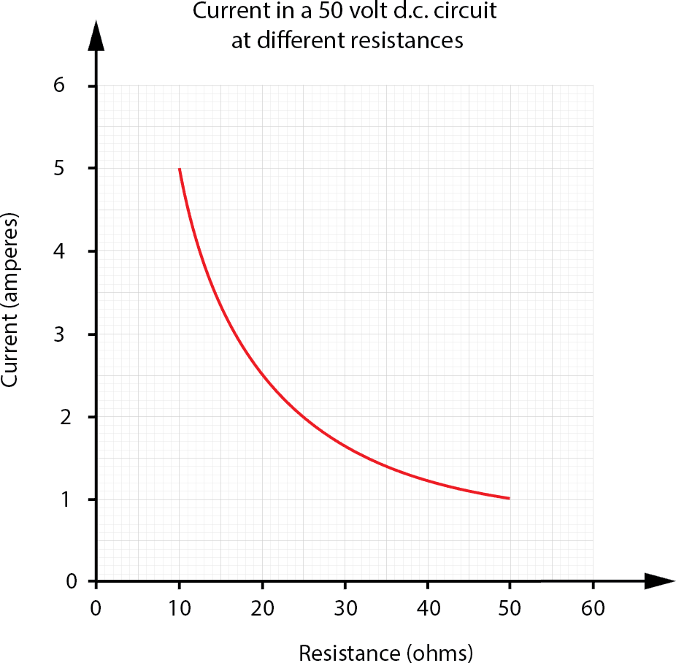

50 V d.c. Circuit
Resistance (ohms) | Current (amperes)
10
20
30
40
50

13/ Express the following statements using indices:

1 ÷ 7 ÷ 7 =

14/ Express the following numbers in scientific notation:

0.00000004 =

15/ Express the following numbers in engineering notation:

a/2,200,000,000 =

b/0.00000104 =

16/ Perform the following SI unit conversions:

0.002 ohms to microhms

17/ Use Ratios to Solve Problems

20,000 to 400

18/ Express each of the following algebraic equations in their simplest form:

T = d(h + 2b + a) + 3(dh + 3bd – 4da)

19/Transpose each of the following equations to make ‘b’ the subject, and express in their simplest form.

- 𝑥 = 𝜋𝑏²

20/
    - Calculate the volume of the following tank. Show all working and provide your answer correctly rounded to three significant figures.

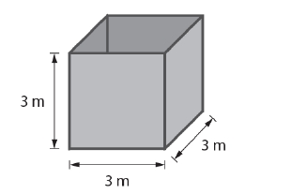

21/Calculate the available roof area
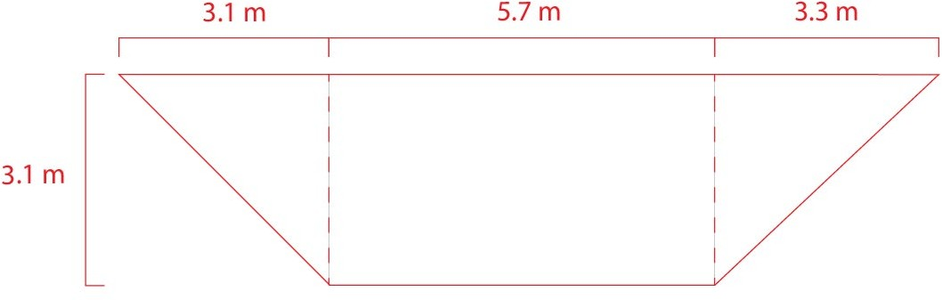²

22 Use Trigonometry Ratios
Sin 30⁰ = | d) | Sin⁻¹ 0.53 =

23/ Use Pythagoras’ Theorem

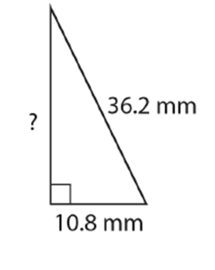

24/Solve Right Angle Triangle Problems

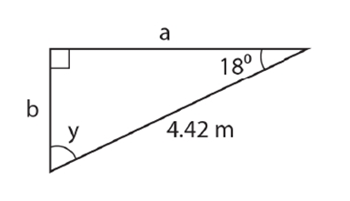

Checkpoint 2 – Numeracy Assessment Assessment / 24 | Satisfactory Yes/No
Description of Item |  | 1st Attempt | 2nd Attempt
Q1
Q2
Q3
Q4
Q5
Q6
Q7
Q8
Q9
Q10
Q11
Q12
Q13
Q14
Q15
Q16
Q17
Q18
Q19
Q20
Q21
Q22
Q23
Q24
Comments:

Part 3 LLN3 (Literacy and Numeracy)

Section 1: Language and Literacy

- Read the following media release then answer the questions that follow:
4 marks
4 April 2011
More maths and physics at school says electrical industry.
(Source: NECA press release)

Today, peak Australian electrical industry body, the National Electrical and Communications Association (NECA), supported calls to place a renewed focus on maths and physics at secondary school.

NECA was responding to an Industry Skills Council that said the average result in some apprentice tests involving maths and physics was 57% compared to 70% in previous years.

NECA chief executive office, Mr James Tinslay, said while the electrical industry was attracting large numbers of apprentices it is still important for the next generation of apprentices to have solid numeracy skills when they leave school and not rely on tertiary education to fill the void.

“NECA has experienced record applications and completion of apprenticeships in its group training companies throughout Australia. It is promising to see so many young people making a career out of learning a trade but it is not surprising when you consider the massive opportunities in the industry,” Mr Tinslay said.

“As the number of new apprenticeships grow to help manage skill shortages in the electrical and communications industry, it is important that vocational training focus on workplace skills and not substitute for schooling.”
With large infrastructure projects such as the National Broadband Network (NBN) and the boom in mining operations in Australia, it is a great time to begin a career in the electrical industry.

“The industry will continue to grow and NECA expects to see more apprentices begin their careers in the coming years. There can be a gap between year 10, year 12 and entry levels of maths and physics required to undertake an electrical apprenticeship, and this needs addressing.

“NECA supports calls for a renewed focus on these skills at secondary school to help students prepare for a career in the electrical and communications industry,” Mr Tinslay said.

- What does NECA stand for?

- What does NECA support?

- What two projects or activities are providing career opportunities in the electrical industry?

- What two subjects should vocational training focus on in secondary schools, in the opinion of the NECA?

- Occupational Health and Safety (OHS) ( 4 marks)
There are agencies in each State and Territory whose primary role is to promote and encourage safe, fair and productive working lives by working with employers, employees, unions and industry representatives. These agencies are responsible for administering industrial relations (IR) legislation and managing OHS functions in each state or territory.

For example, SafeWork SA is South Australia's occupational health, safety and welfare (OHS) agency. The following extract is from the SafeWork SA website – www.safework.sa.gov.au
Read the extract and answer the questions on the following pages:
Hierarchy of control measures

The hierarchy of control is a sequence of options which offer you a number of ways to approach the hazard control process. Everyone in the workplace must adhere to the OHS policies and procedures. Here is a list of some OHS policies and procedures, with typical examples.

Eliminate the hazard:
- Remove hazardous electrical plants from the workplace;
- Cease in-house operations of hazardous work.
If this is not practical, then…

Substitute the hazard with a lesser risk:
- Use low voltage electrical plant;
- Substitute movable electrical plant for fixed.

If this is not practical, then…

Isolate the hazard:

- Place hazardous electrical plant in enclosures with restricted access;
- Place out-of-service tags on plant.

If this is not practical, then…

Use engineering controls:

- Use RCDs (safety switches) to protect socket outlets which supply electrical plant.
If this is not practical, then…

Use administrative controls:
- Perform regular inspection and tests on electrical plant and electrical installations;
- Implement safe work practices, instruction and training.

If this is not practical, then…
Use Personal Protective Equipment (PPE):
Use rubber mats, insulated gloves, eye protection, boots, and head gear (also to be used in conjunction with above measures).

Examples of some Personal Protective Equipment (PPE) and safety signs that may be used in the Electrical Trades:
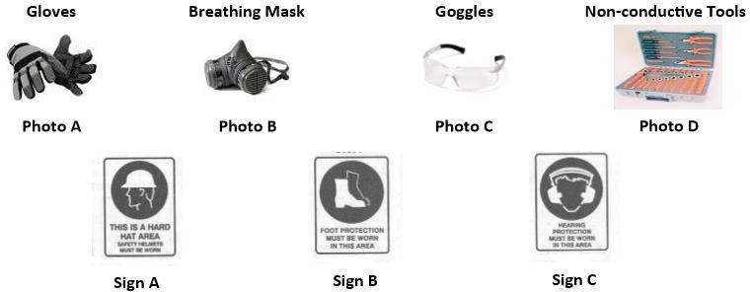

Answer the following questions:
  - Where does Personal Protective Equipment stand on the hierarchy of control?

  - How do you eliminate a hazard?

  - What are RCDs and why are they used?

  - What is the role of each state and territory OHS agency?

  - Name at least two PPE items to use when installing a light fitting overhead:

Section 2: Numeracy
Each 1 mark
- Match the type of number with the examples provided:
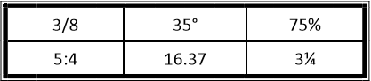

a. Percentage
b. Decimal Number
c. Fraction
d. Mixed Number
e. Ratio
f. Angle

- Arrange in ascending order: (from smallest to largest)
4 -2 ½ 3.7 0 -8

- Write in descending order: (from largest to smallest)
¼ ⅔ 0.3

- Express the following in scientific notation:

a. 17,601
b. 729,123
c. 0.00015
d. 12.72
5. Calculate the following:
a. 10²
b. 3S
c. √36
d. ( √9 )²
6. Add the following:
a. $2, $21.45 and $8.23
b. 18.32, 471.019 and 315
7. Calculate the following:
a. 5,218 - 1,784
b. 43.18 - 29.461
8. Multiply the following:
a. 6.87 by 10
b. 13.8 by 3
c. 46.2 by 8.5
9. Divide the following:
a. 3.45 by 10
b. 3,024 by 14
c. 56.2 by 0.2
10. Simplify the following:
a. 2 + 3 x 4
b. 4 – 10 ÷ 2
50+50
c.
2 ×25
d. (16 –5) x 3

11. Add the following:
a. ¼ and ½
2
b. 9 and 6
c. 3¼ and 1/8

12. Calculate the following:
5 1
a. −
6 4
b. 2 1/ − 4
14 7

- Evaluate the following:
  - 10% of $44
b. 25% of 12.84

14. Michelle is a first-year apprentice who earns $600 a week as an apprentice electrician. She gets a pay rise of 5%. What is her new wage?

- An article bought for $250 is sold for $375. Find:

a. The profit in dollars.
b. The profit as a percentage of the cost price.

- Jonas, an electrician, buys the following from an electrical wholesaler: cable $215; power points $95; and fixings $8. Jonas receives a 10% trade discount.

a. How much would Jonas pay with no discount?
b. How much would Jonas pay with discount?
c. How much has Jonas saved?

- Barry scored 80% in an exam. There were 25 questions.

a. How many questions did Barry get right?
b. How many questions did Barry get wrong?

- What percentage is 30 out of 50?

19.Electrical goods are subject to a goods and services tax (GST) of 10% of the sale
price. If a refrigerator’s pre-tax price is $850:

a. What is the tax?
b. What is the selling price?

20.The efficiency of a machine is rated at 70%. If the input to the machine is 200 watts, what is the output power available?

21.Remove the brackets and simplify the following:

a. (2x + y) - (x - 4y)
b. (3a - b) - (2a - 3b)

22.If P = F/A find P, if F = 60 and A = 20?

23.Re-arrange the following formulae to make the letter in brackets the subject of the formula:

a. P = VI (V)
b. P = ^{𝜋𝑄𝑛} (Q)
30

24.The formula for working out the voltage is V = E - iR. Re-arrange the formula to:

a. Make E the subject
b. Make R the subject

25.The ratio of a diameter of ‘pulley A’ to ‘pulley B’ is 4.5 to 2. If ‘pulley A’ has a diameter of 450 mm what is the diameter of ‘pulley B’?

26.What is the ratio of the number of light bulbs to double power points?


27.The mass of two resistor boxes are in the ratio of 2:5. The smaller box has a mass of 20 kg. What is the mass of the larger box?

28.Convert 5 amps to milliamps (mA):

29.Convert 12k ohms to ohms (Ω):

30.A large washer has an outer radius of 10 mm and a hole with a diameter of 14 mm.
What is the area of the washer? (Use π = 3.14):
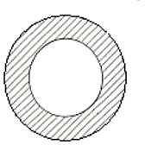
31.Calculate the area of the solar panel which has a base length of 1.5 m and a height of 1.75 m:
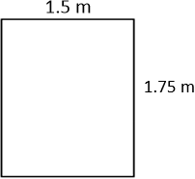

32.An electric car is travelling at 60 km per hour, how far will it travel in 3 hours?

33.Two numbers add up to 40. Find the other number if one of the numbers is 15:

34.Meeha is a data-cabling technician. She receives a gross salary of $45,000 a year. How much does she receive each fortnight?

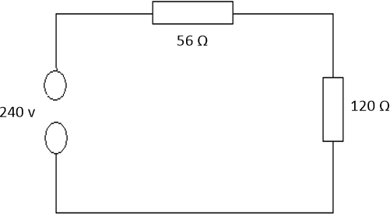
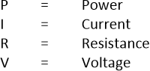
35. simple circuit has two resistors, one 56 ohms and the other is 120 ohms, and is connected to a supply voltage of 240 volts. Answer the questions on the next page:
  - Calculate the current flowing (in amps) in the circuit using the formula V=IR correct to 3 decimal places:

  - Calculate the total power (in watts) dissipated using the formula P = I2R.
For ‘I’, use the answer you calculated in the previous question, correct to 2 decimal places:

36.A right-angled triangle has the following dimensions. Using Pythagoras’ Theorem
find the missing side (b):

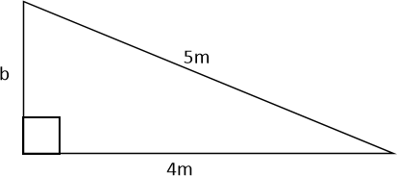

37.The perimeter of a room needs to be wired. The room measures 3.2 m x 3.2 m:

  - How much wire is required to go around the outside of 3 of the walls?

If Thermo Plastic Sheathed (TPS), Orange Circular and Category 6 (cat6) cable are all to be used when wiring the 3

Checkpoint 3 – Literacy Numeracy Assessment Assessment / 45 | Satisfactory Yes/No
Description of Item |  | 1st Attempt | 2nd Attempt
Literacy
Q1 4 marks
Q2 4 marks
Numeracy Each 1 mark
Q1
Q2
Q3
Q4
Q5
Q6
Q7
Q8
Q9
Q10
Q11
Q12
Q13
Q14
Q15
Q16
Q17
Q18
Q19
Q20
Q21
Q22
Q23
Q24
Q25
Q26
Q27
Q28
Q29
Q30
Q31
Q32
Q33
Q34
Q35
Q36
Q37
Comments:

