BAE 623 Surveying & Traffic Engineering
Part (1) Airport Engineering
(1) What are the important factors to be considered in run way orientation of airport?

(2) Explain wind rose diagram by two methods.

(3) Refer the following wind rose diagram & information, find the best run way orientation.
- Wind coverage = 95%
- (i) cross wind component = 15kmph ➔

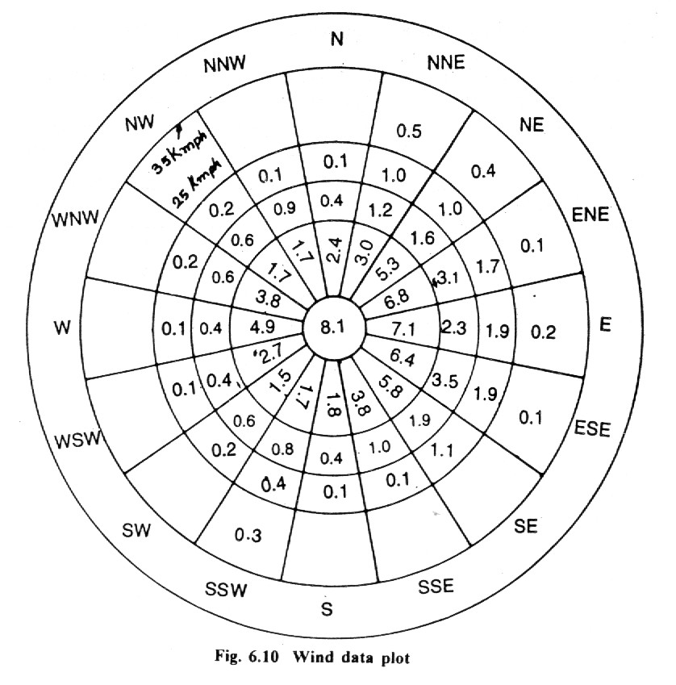
Part (2) Traffic Engineering
(4) Explain AASHTO Design Method

(5) Describe road construction materials.

(6) What are the factors that determine the reliability of highway?

(7) Design the highway based on given data.
Given
- Flexible Pavement
- Urban Interstate Highway
- ESAL = 2 x10⁶
- a week for water to be drain with in moisture level = 30%
- M_{r} of AC at 68 F = 45000psi
- CBR value of base = 100, M_{r} = 31000psi
- CBR value of sub base = 22, M_{r} = 13500psi
- CBR of Sub grade = 6

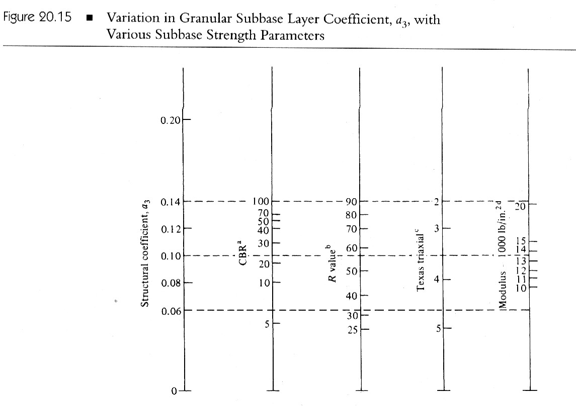
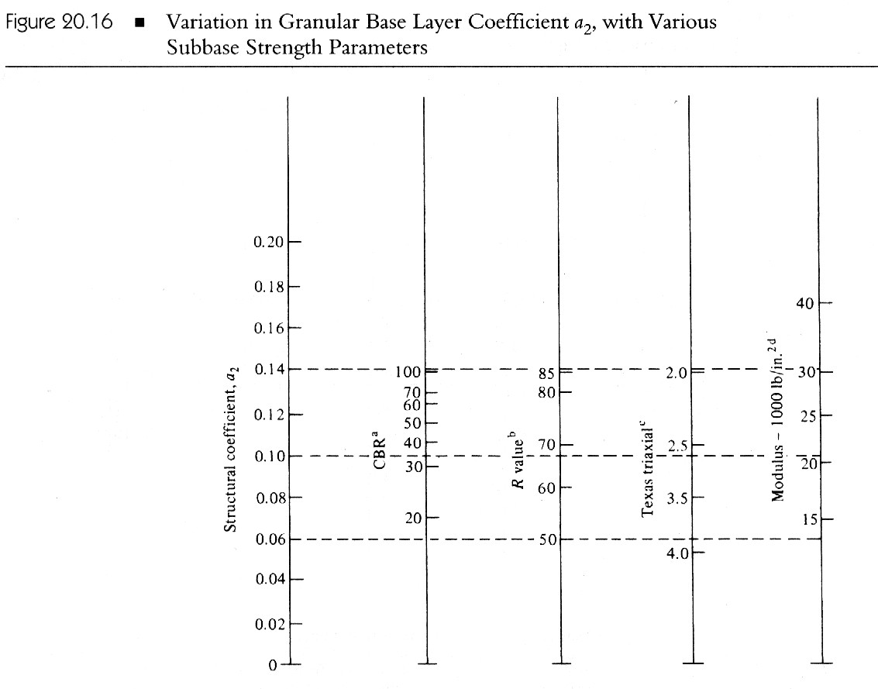

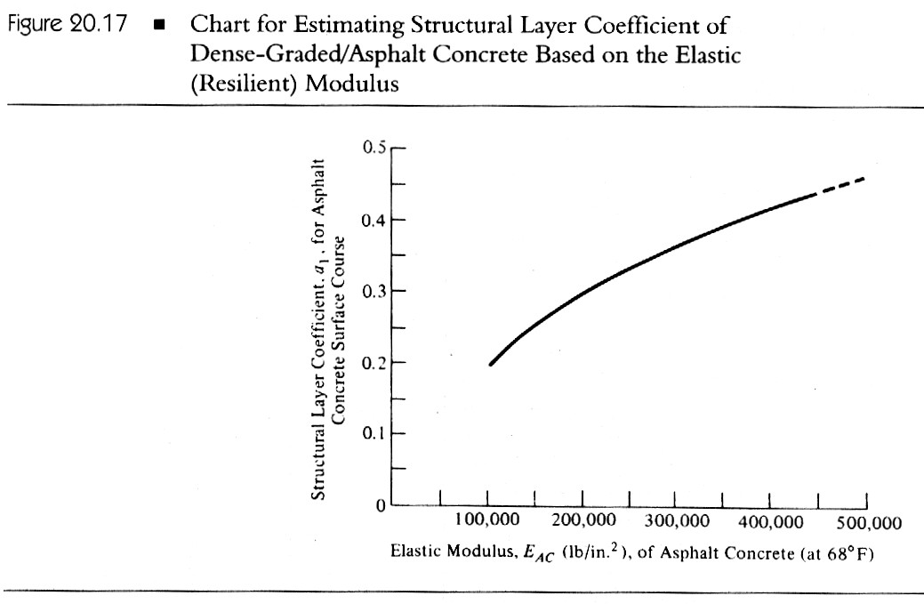
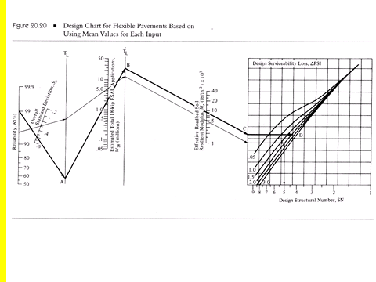
Part (3) Transport Engineering

(8) What is transportation planning?

(9) Describe the ways of approach in urban transport planning.

(10) Write the processes in urban transport planning and describe any three processes in details.

(11)Explain Trip generation analysis.

(12)

Assuming that this is your last term at your University, you have passed the final examination and are ready to pack everything up to go home. After several term of studying at your University, lots of books papers and notes have been accumulated, say more than 100 kg. Your home is far away from your University’s city, and it can be reached by four transportation modes, i.e, highway, railroad, airport and port. Since you have to work hard to finish your degree here, you do not have to time to earn other income. As a student with limited budgets, you want to find the most economic way to send your stuffs home. However, you are not concerned about how fast your stuffs can be delivered home. Which transportation mode will be your best selection? Explain the reason.

