BAE 421 Building Construction Engineering

- What are the types of doors & windows

- Outline the followings
- Types of buildings
- Types of trusses
- Indicate the components of the given building diagram

- Based on the following plan, develop the front & side views of the building.
- What are the components of culvert & bridge diagrams?

- What are the components of building diagrams?

- Summarise the mixed design process.

- Design the following building
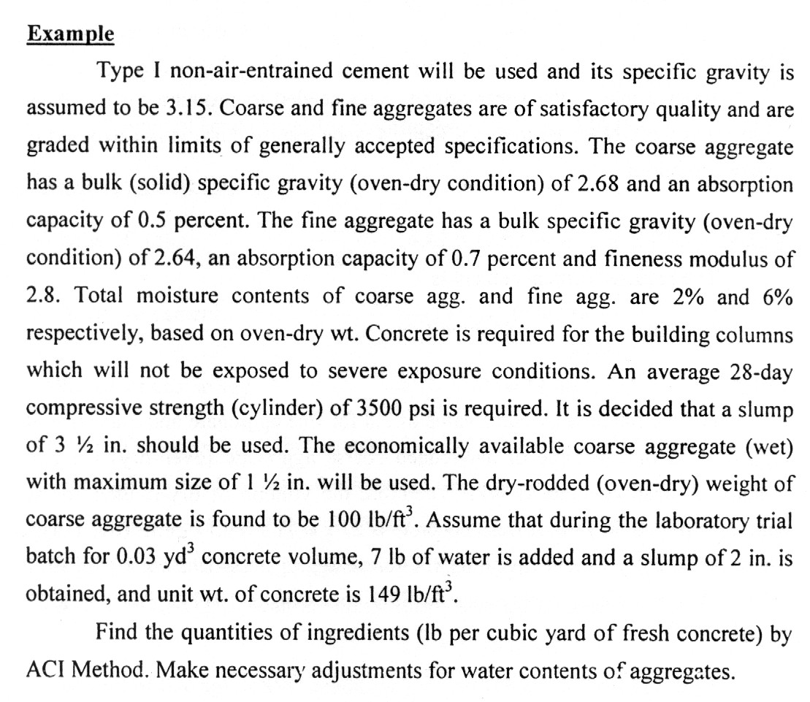
- What is ACI 211.1?

(10) Explain choice of slump

