AutoCAD 2004

ICPMM42cA Incorporate 2D graphics into multimedia presentations

Incorporate 3D modelling into multimedia presentations

To start the AutoCAD Program

Click AutoCAD Icon

TO DRAW LINE

Draw---Line OR Click Line Icon

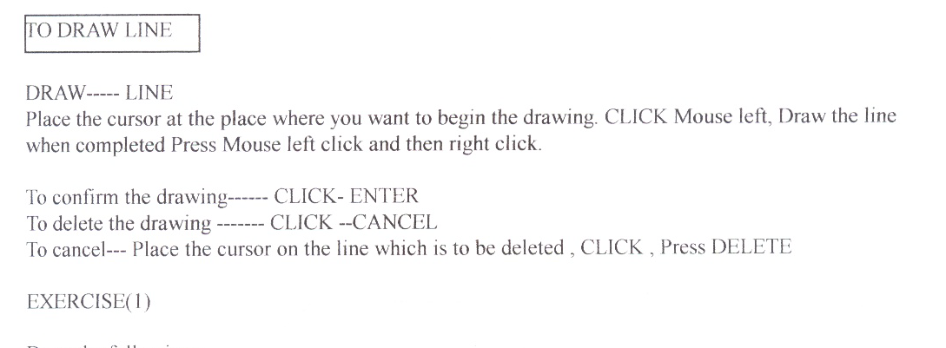

Exercise (1)

Draw the followings

Exercise(2)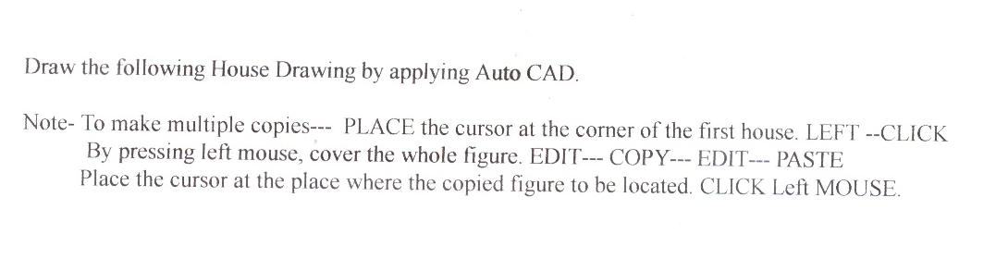

Exercise (3)
Draw the followings.

Freehand Sketches

Click the free hand sketch icons on the menu and draw the followings.
Note. Draw the curve to one direction by clicking left button on the mouse. To stop the drawing or to change the direction, release left button.

To draw the curve

Click the curve icon.
Click left button on the mouse. While pressing, draw the line and release.
If you want the curve bend to downward, press the left button of the mouse and move the mouse to upward while pressing. To stop bending release the left button..

Exercise (4) Draw the followings

To insert the colour.

To insert colour, click object

Click the colour menu box
(If the menu box is not on the screen, View-- tool bar—properties—Click □ By layer

Click colour, Select colour, ESC

Exercise (5) --- Change the colour of your drawings
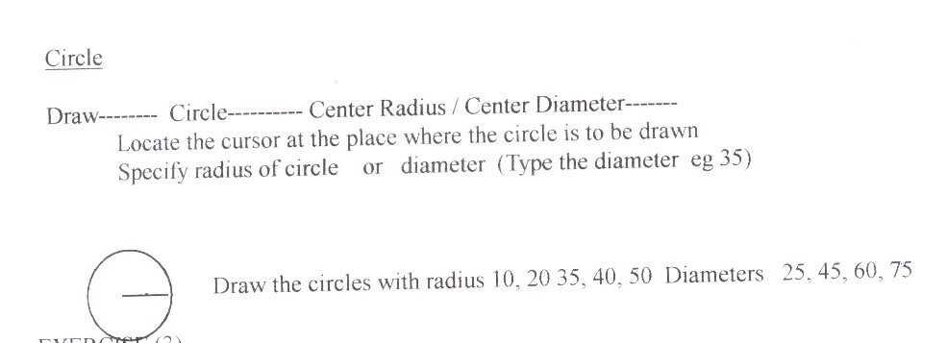

Exercise (6)
Draw the following circles of radii 1,2,3,4

Exercise (7)
Draw the followings

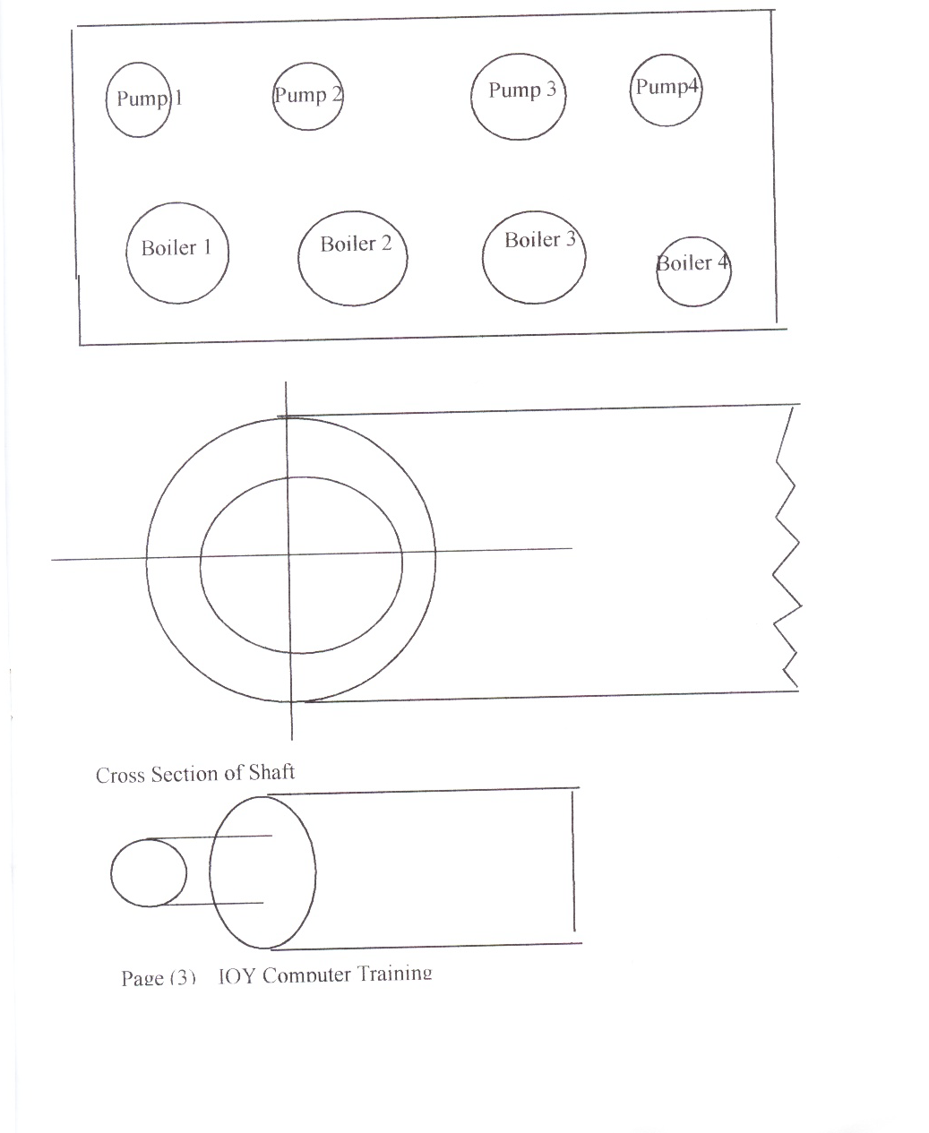

INSERTING LETTERS

Draw—Text—Single line text—Locate the cursor where the text is to be inserted—Text height: 2 Enter--- Rotate Angle --0 (For horizontal)
Then type 10mm

Draw—Text—Single line text—Locate the cursor where the text is to be inserted—Text height: 2 Enter--- Rotate Angle --90(For vertical)---Enter
Then type 2mm

Draw—Text—Single line text—Locate the cursor where the text is to be inserted—Text height: 2 Enter--- Rotate Angle --30--Enter
Then type 3mm

Draw—Text—Single line text—Locate the cursor where the text is to be inserted—Text height: 2 Enter--- Rotate Angle --45---Enter
Then type 35 mm

Draw—Text—Single line text—Locate the cursor where the text is to be inserted—Text height: 2 Enter--- Rotate Angle --120--Enter
Then type 120 mm

Exercise (8)

Exercise (9)

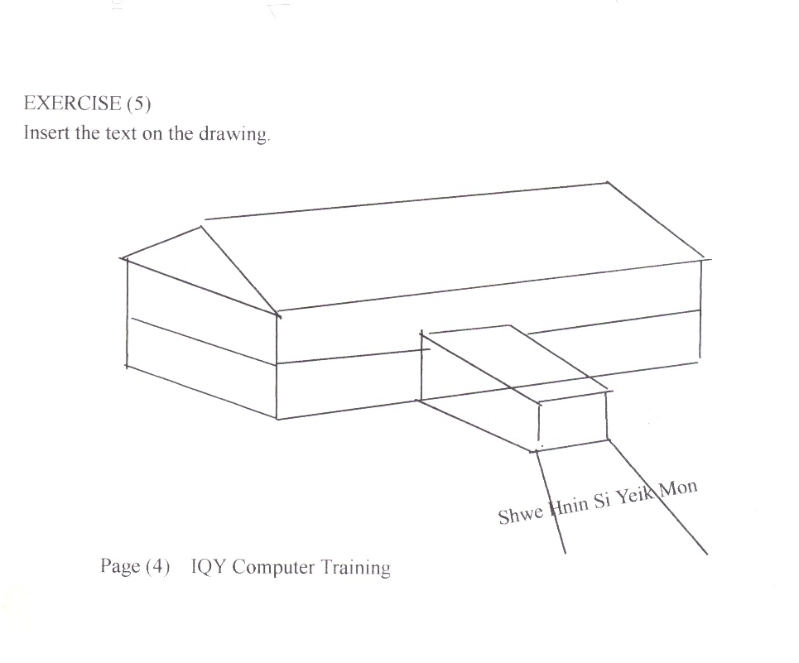
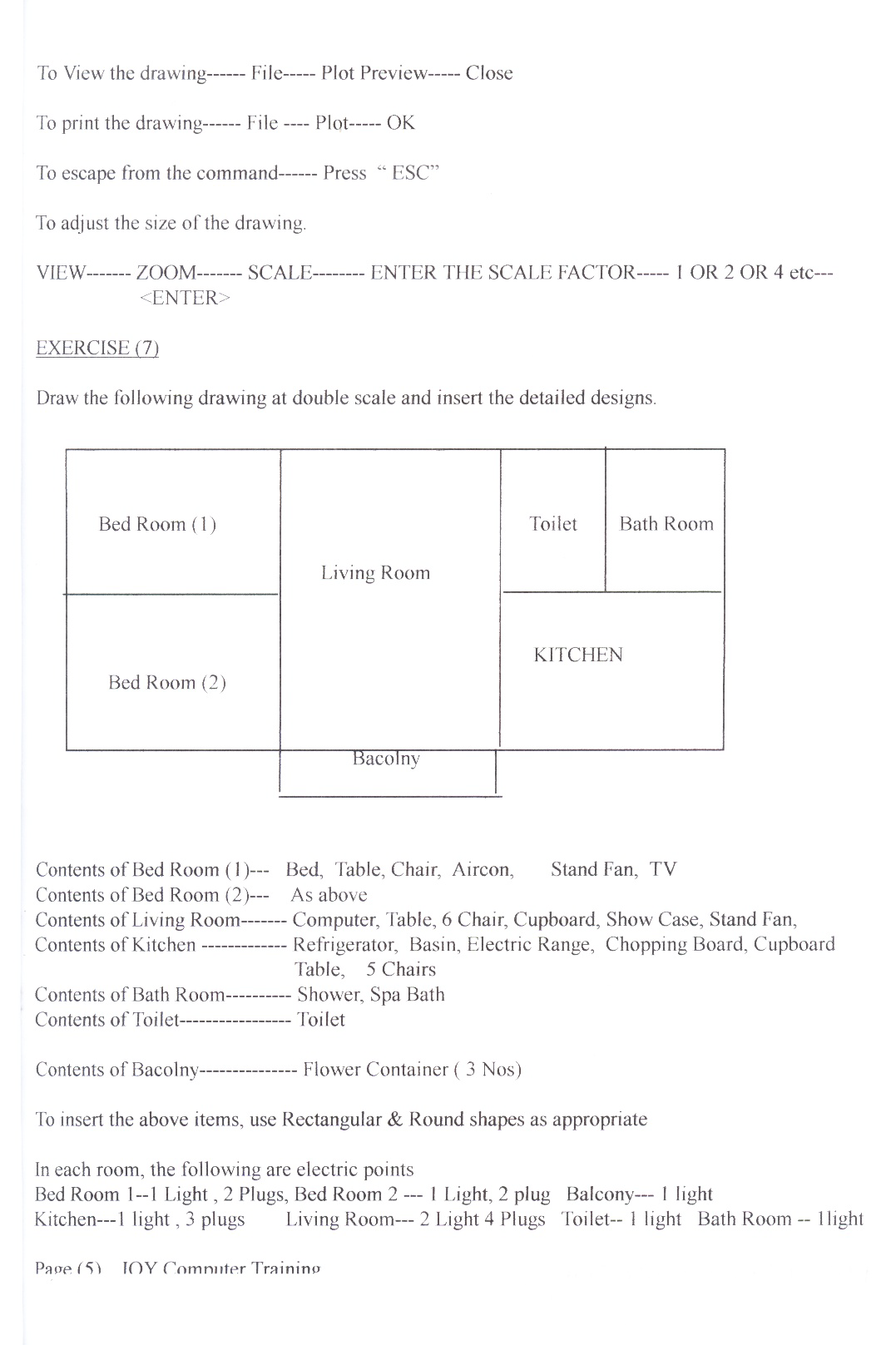
Inserting 2D Figures


Exercise (10)

Draw the followings

To Draw Polygons
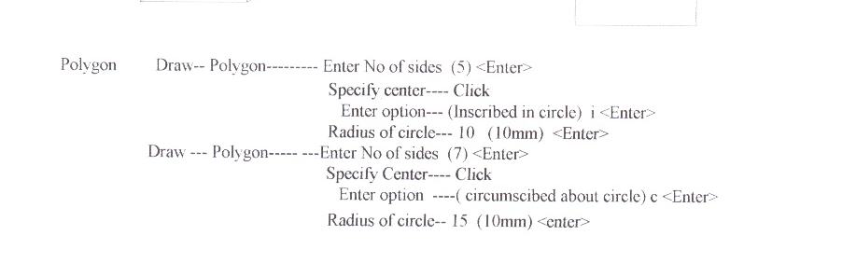
Exercise (11)

Draw the followings
Pentagon , Incribed circle, Radius 2
Hexagon- Incribed Circle- Radius 3
Octagon-Incribed Circle- Radius 5
To draw 3D Objects

Draw –3D Poly lines
Click the mouse left button

And then draw the line- at the corner- release the mouse button- then press the mouse left button and draw the another line until to form the following shape

Then continue the followings.
When the above form has been drawn, click left button and then click right button to enter.
Draw –3D Poly lines
Click the mouse left button

And then draw the line- at the corner- release the mouse button- then press the mouse left button and draw the another line until to form the following shape

Then continue the followings.
When the above form has been drawn, click left button and then click right button to enter.
Draw –3D Poly lines
Click the mouse left button

And then draw the line- at the corner- release the mouse button- then press the mouse left button and draw the another line until to form the following shape

Exercise (12)
Draw the following 3d Figures.

To Draw Arc

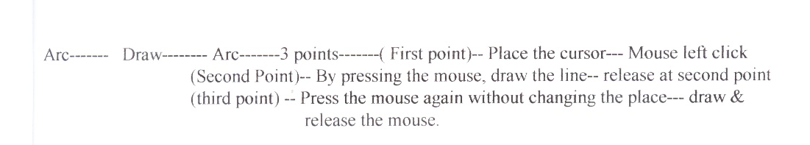

Exercise (13)
Draw the following arcs

Exercise (14)

Draw the following figure

Exercise (15)
Draw the following figures.
Exercise (16)
Draw the following figure

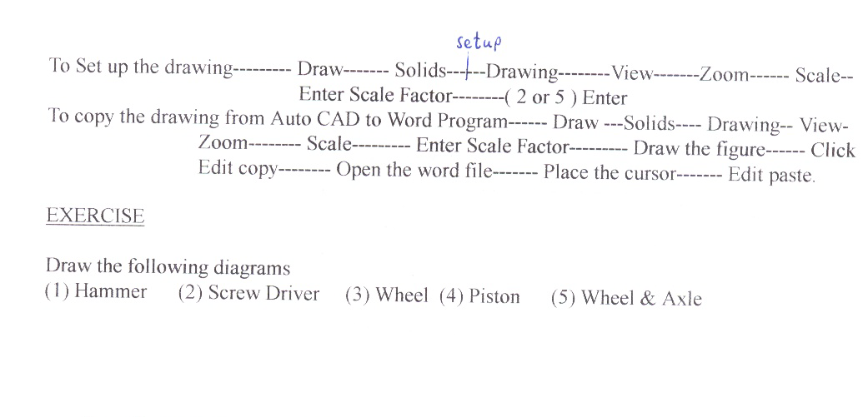
Exercise (17)
Draw the following picture.

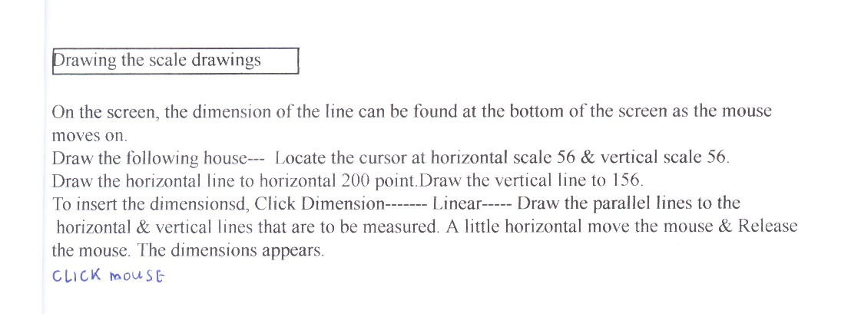
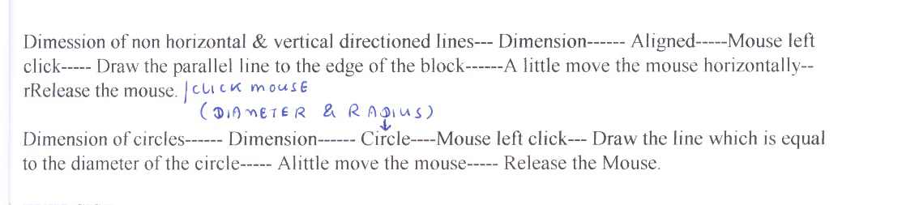
Exercise (18)
Draw the following figure.

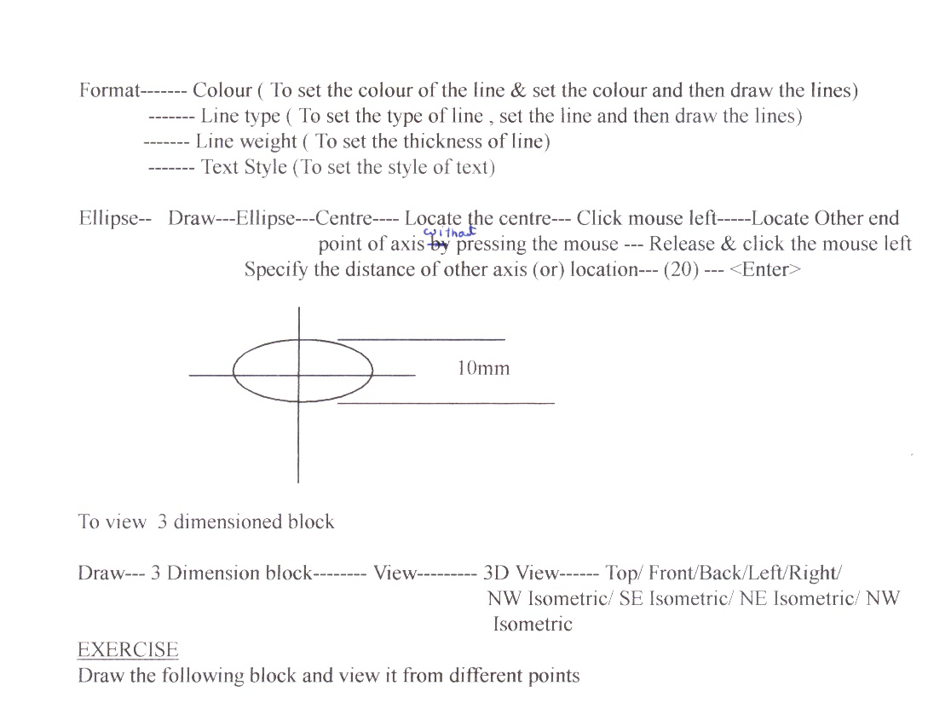

NE Isometric View
NW Isometric

SE Isometric

SW Isometric

Exercise (20)

Draw the following Ellipses

2D, 3D Design

- Create 2D, 3D Design / Drawings by using AutoCAD, Corel draw.

- As Macromedia Dreamweaver can not directly accept the graphics created by using AutoCAD and Corel Draw, Firstly convert those graphics into Word File from Corel Draw/ AutoCAD Programs.

- Then save the file into HTML/ Web Page

- Then Use Macromedia Dreamweaver to open the Web/ HTML File that contains the graphic.

  - By this way the graphic files can be converted to Macromedia Dreamweaver MX File.

Practical

- Create 2D/ 3D Graphics by using AutoCAD/ Corel Draw
- Transfer the files into Word File
- Save the file into Web/ HTML Format
- Use Macromedia Dreamweaver MX to open the file
- Then modify the page

ASSESSMENT

ICPMM42cA Incorporate 2D graphics into multimedia presentations

Name of Student

Topics | Descriptions | Assessment Method | Complete  or  Not Complete
Technical requirements for preparing artwork for multimedia output | A design brief is assessed for the appropriate digital imaging solution  Graphics that incorporate the principles of design are created using the designated software to produce bitmapped or Vector graphics and digital artwork  2D digital artwork techniques are demonstrated including the correct use of painting, editing and pallets  Graphic designs are edited, (enhanced and amended) using accurate selection techniques, special effects, cropping and resizing of images, and saved using the designated software  The elements of graphic design are integrated into a designated multimedia sequence  The graphics are to be inserted into Powerpoint, MS Front Page | Practical Task
Recognition and how to use and apply different technologies for design purposes | Graphics are tested and run as part of a multimedia presentation  Digital images are professionally mounted for presentation using the mount cutter  Graphics are titled and laminated to presentation size  Non-colour-fast digital artwork is presented under screened glass or Perspex  Images are published electronically if required | Practical Task
Ability to use digital collages and montages and other presentation techniques | Digital collages and montages are created by adjusting image mode and resolution, modifying image using filters, selecting the correct colour mode for the output

Date of Assessment

Student’s Signature

Assessor’s Signature

Grade

ICPMM47DA

Incorporate 3D modelling into multimedia presentations

Name of Student

Element | Performance Criteria | Mode | Complete  Not Yet Complete
Identify and describe formats of 3D Modelling | - A range of 3D modelling software are identified and distinguishing features examined  - Contemporary 3D modelling software is selected appropriate to a range of given outcomes  - Limiting factors of computer hardware on 3D modelling production are identified  - The digital medium for 3D is explained for a specified job  - The formats employed to create a given 3D model are analysed and discussed for a specified job
Use 3D modelling software | - Appropriate 3D modelling software is assessed and selected for the job  - Entering and exiting the selected 3D modelling software are demonstrated and the tools and features of the program used correctly  - Editing and manipulating 3D models are demonstrated and the tools and features of the program used correctly  - 3D modelling editing software is used to combine given video assets  - 3D model is saved and retrieved using the designated file formats

Design and edit a 3D model | - 3D modelling software is selected appropriate to the required outcome  - 3D object is created using software commands  - 3D virtual model space is created using software commands  - Boolean operations and Vector based drawings are created relevant to a 3D model  - Predefined textures are applied to a control model using texture mapping parameters  - Visual mood and colour tones are used to control model and virtual space  - Lighting and shadows are added to the 3D model to define texture  - Camera control options are defined and manipulated to achieve the visual objective  - Object motion hierarchies are demonstrated and used to achieve a motion effect
Present a 3D modelling sequence | - 3D model motion is tested and combined with other digital imaging, sound and/or animation / video to create a multimedia sequence with regard for cross platform file transfers, digitised time coding and interface calibration  - The multimedia sequence including 3D modelling is saved and presented with reference to file compression technology

Student’s Signature

Assessor’s Signature

Grade

Date of Assessment

